**Topics: Descriptive Statistics and Probability**

1. **Look at the data given below. Plot the data, find the outliers and find out $μ, σ, σ^{2}$**

| **Name of company** | **Measure X** |
| --- | --- |
| Allied Signal | 24.23% |
| Bankers Trust | 25.53% |
| General Mills | 25.41% |
| ITT Industries | 24.14% |
| J.P.Morgan & Co. | 29.62% |
| Lehman Brothers | 28.25% |
| Marriott | 25.81% |
| MCI | 24.39% |
| Merrill Lynch | 40.26% |
| Microsoft | 32.95% |
| Morgan Stanley | 91.36% |
| Sun Microsystems | 25.99% |
| Travelers | 39.42% |
| US Airways | 26.71% |
| Warner-Lambert | 35.00% |

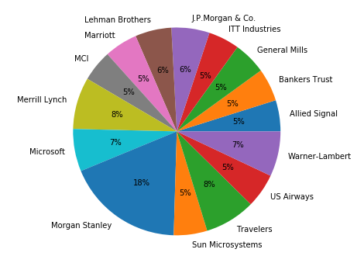

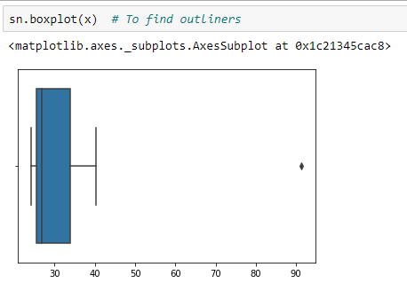

Mean = 33.27133333333333, Variance = 287.1466123809524, Standard deviation = 16.945400921222028

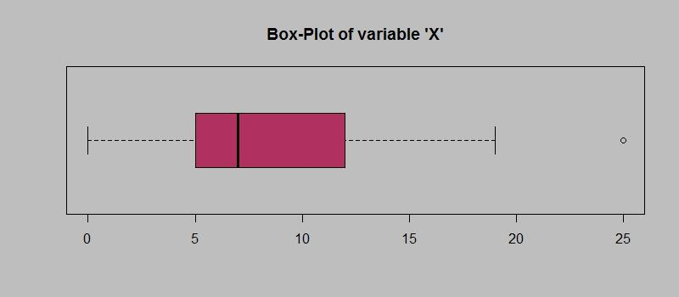

**Answer the following three questions based on the box-plot above.**

1. **What is inter-quartile range of this dataset? (please approximate the numbers) In one line, explain what this value implies.**
2. **What can we say about the skewness of this dataset?**
3. **If it was found that the data point with the value 25 is actually 2.5, how would the new box-plot be affected?**

* (i) First Quantile Range (Q1) = 5, Third Quantile Range (Q3) = 12, Median (Second Quartile Range) = 7, Inter-Quartile Range (IQR) = Q3 – Q1 = 12 – 5 = 7. Second Quartile Range is the Median Value

IQR tells us the range of the middle half of the data. It means 50% of data points lie in

the range of 5 and 12

(ii) The dataset is positively skewed

(iii) The median value will remain same, but the interquartile range will change. There would be no Outliers on the given dataset because of the outlier the data had positive skewness.

The boxplot might have moved towards right slightly.

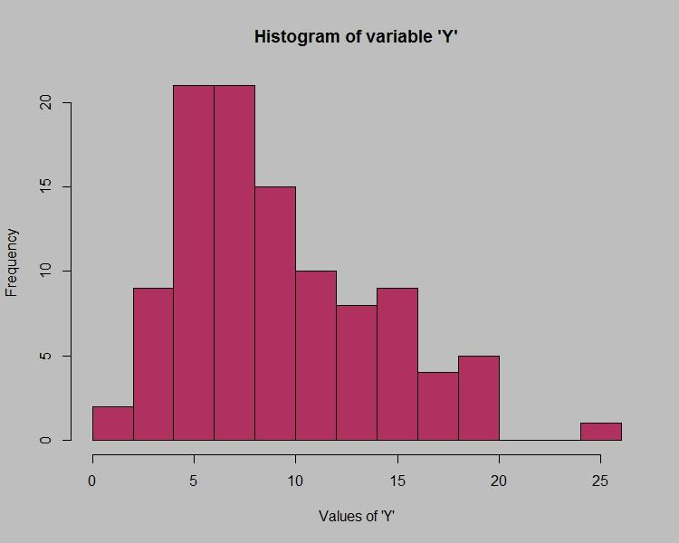

**Answer the following three questions based on the histogram above.**

1. **Where would the mode of this dataset lie?**
2. **Comment on the skewness of the dataset.**
3. **Suppose that the above histogram and the box-plot in question 2 are plotted for the same dataset. Explain how these graphs complement each other in providing information about any dataset.**

* (i) The mode of this data set lie approximately in between 4 to 8

(ii) The dataset is positively skewed

(iii) By comparing both of them it is very clear that the data would be positively skewed. both have outliers the median can be easily visualized in box plot where as in histogram mode is more visible.

1. **AT&T was running commercials in 1990 aimed at luring back customers who had switched to one of the other long-distance phone service providers. One such commercial shows a businessman trying to reach Phoenix and mistakenly getting Fiji, where a half-naked native on a beach responds incomprehensibly in Polynesian. When asked about this advertisement, AT&T admitted that the portrayed incident did not actually take place but added that this was an enactment of something that “could happen.” Suppose that one in 200 long-distance telephone calls is misdirected. What is the probability that at least one in five attempted telephone calls reaches the wrong number? (Assume independence of attempts.)**

* Probability o call geng misdirected = (1/200)

Hence probability o call not geng misdirected = 1-(1/200) = 199/200

Number of phone calls attempted = 5

P(x) = ⁿCₓpˣqⁿ⁻ˣ

n = 5

p = 1/200

q = 199/200

= 1 - none of the call reaches the wrong number

= 1 - P(0)

= 1 - ⁵C₀(1/200)⁰(199/200)⁵⁻⁰

= 1 - (199/200)⁵

= 0.02475

Therefore, probability that at least one in five attempted telephone calls reaches the wrong number = 0.02475

1. **Returns on a certain business venture, to the nearest $1,000, are known to follow the following probability distribution**

| x | P(x) |
| --- | --- |
| -2,000 | 0.1 |
| -1,000 | 0.1 |
| 0 | 0.2 |
| 1000 | 0.2 |
| 2000 | 0.3 |
| 3000 | 0.1 |

1. **What is the most likely monetary outcome of the business venture?**
2. **Is the venture likely to be successful? Explain**
3. **What is the long-term average earning of business ventures of this kind? Explain**
4. **What is the good measure of the risk involved in a venture of this kind? Compute this measure**

* (i) The most likely monetary outcome of the business venture is 2000$. As for 2000$ the probability is 0.3 which is maximum as compared to others

(ii) Yes, because the total earnings of the venture is positive in value i.e 800 and highest probability of earning is 2000

p(x>0)+p(x>1000)+p(x>2000)+p(x=3000) = 0.2+0.2+0.3+0.1 = 0.8

(iii) The long-term average is Expected value = Sum (X * P(X)) = 800$ which means on an average the returns will be + 800$

(iv) The good measure of the risk involved in a venture of this kind depends on the Variability in the distribution. Higher Variance means more chances of risk Var (X) = E(X^2) –(E(X))^2 = 2800000 – 800^2 = 2160000